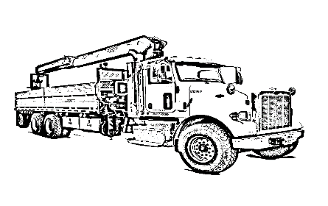

Employment Application
KENNESAW DRYWALL & SUPPLY, INC.

Programs, services and employment are equally available to everyone. Please inform the Human Resources Department if you require reasonable accommodation for the application or interview. | Date of Interview (Month/Day/Year):  / /
Applicant Data | Position Applied for:
How were you referred to us:
Full Name: DOB:

Address: City: State: Zip:
Phone: | Mobile: E-mail:
Date Available to Start: | Social Security Number: - - Salary Requirements:
If you are under 18 years of age,  can you provide a work permit? | ❑ Yes  No If no, please explain:
Have you ever worked for this company?  Yes  No |  | If yes, when?
Are you a citizen of the United States?  Yes  No
If not, are you legally allowed to work in the United States?  Yes  No

Type of employment desired:  Full-Time  Part-Time  Temporary  Seasonal
Have you ever pleaded guilty, no contest or been convicted of a crime?  Yes  No If yes, give dates and details:

Answering yes to these questions does not constitute an automatic rejection for employment. Date of the offense, seriousness and nature of the violation, rehabilitation and position applied for will be considered.  Driver's license number (if applicable to position): | State:
Summarize Your Special Skills or Qualifications

Previous Employment (begin with most recent position)
Dates of Employment: From____/____/____ To____/____/____ Position(s) Held:
Company Name: Address:
City: State: |  |  | Zip:
Phone: | Supervisor: | Title:
Responsibilities:
Starting Salary and Title: |  | Ending Salary and Title:
Reason for Leaving:

May we contact this employer for a reference?  Yes  No

Dates of Employment: From____/____/____ To____/____/____ Position(s) Held:
Company Name: Address:
City: State: |  |  | Zip:
Phone: | Supervisor: | Title:
Responsibilities:
Starting Salary and Title: |  | Ending Salary and Title:
Reason for Leaving:

May we contact this employer for a reference?  Yes  No
Dates of Employment: From____/____/____ To____/____/____ Position(s) Held:
Company Name: Address:
City: State: |  |  | Zip:
Phone: | Supervisor: | Title:
Responsibilities:
Starting Salary and Title: |  | Ending Salary and Title:
Reason for Leaving:

May we contact this employer for a reference?  Yes  No
I certify that my answers are true and complete to the best of my knowledge. I authorize you to make such investigations and inquiries of my personal, employment, educational, financial and other related matters as may be necessary for an employment decision. I hereby release employers, schools or individuals from all liability when responding to inquiries in connection with my application.

In the event I am employed, I understand that false or misleading information given in my application or interview(s) may result in discharge.
Signature of Applicant: Date:

ALL EMPLOYMENT APPLICATIONS CAN BE RETURNED VIA FAX: (770) 424-7719 OR E-MAIL: KENNESAWDRYWALLSUPPLY@GMAIL.COM

